|  |  |
| --- | --- |
| Date: | 27 February 2014 |
| Name: | Jesse Roy James II |
| Course: | APD |
| Director: | Wendy Jones |
| document: | Application Design Document |
| Video Game SEarch  Pitch Video:[Pitch video](http://www.youtube.com/watch?v=UfALQkSTqUk) | |

Application Definition Statement

a

|  |
| --- |
| Purpose or Main Intent |
| This application’s main purpose is to provide a user with the ability to utilize a large video game database to find a game they are looking for and then be able to look at detailed information about that video game. |
| Description of Intended Audience |
| The intended audience of this application would be people who are looking for video games and may not remember the whole name of the game. This application will allow them to search through and find the game. |
| Core Functionality |
| Video game search will utilize a simple approach to a search feature with box art examples being posted as part of the search results so that the user can make a little better of a determination prior to clicking on each game. |

Application User Feature Set

# Main Features

* Users can utilize the search feature to search for any video game.
  + A box art picture when available will detail games.
  + A game rating when available.
  + Publisher
  + Developer
  + Number of players
  + Co-op compatibility
  + Genre

Application Layout

# Title Screen



# Main UI

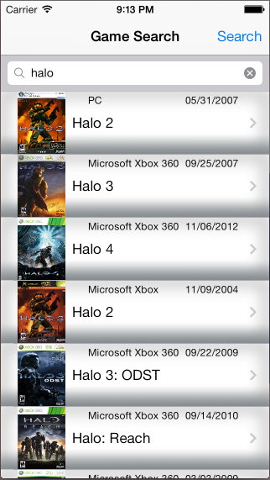

Game Detail Page

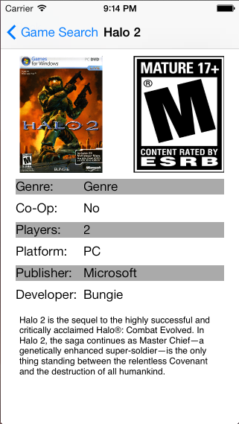

Application Flow

